**Logging using SLF4J**

**Exercise 1: Logging Error Messages and Warning Levels**

Task: Write a Java application that demonstrates logging error messages and warning level using SLF4J.

Step-by-Step Solution:

1. Add SLF4J and Logback dependencies to your `pom.xml' file:

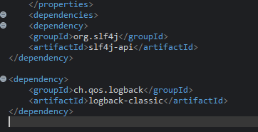

2. Create a Java class that uses SLF4J for logging:

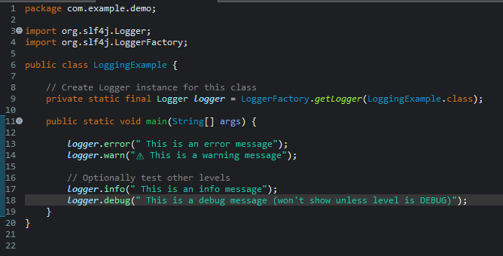

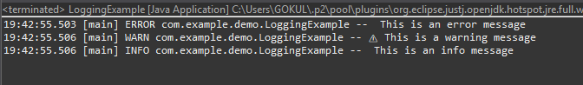

**Cleaner Syntax**: It allows inserting variables into log messages using {} placeholders, avoiding string concatenation.

**Improved Performance**: Parameters are only evaluated if the log level is enabled, which avoids unnecessary computation.

**Easy to Read**: Logs with placeholders are easier to read and maintain, especially when there are multiple variables.

**Supports Multiple Parameters**: You can pass multiple values to a single log statement using multiple {} placeholders.

**Error-Free Logging**: Helps reduce bugs from incorrect string building or formatting, especially when logging user input or system state.

**Best Practice in Java**: It is the recommended logging approach when using SLF4J or frameworks like Spring Boot.